**Ecuación diferencial para resolver la viga de wincler**

**%V' == -k*v+q (1)**

**%M' == V (2)**

**%t' == M/EI (3)**

**%v' == t - V/Ac (4)**

**%derivo (2)**

**%M''=V' (5)**

Remplazo (5) en (1)

**M’’= -k*v+q (6)**

**%derivo (6)**

**M’’’= -k*v’+q’ (6)**

**-M’’’= k*v’-q’**

**v’=(q’-M’’’)/k**

**% reemplazo (6) en (4)**

**(q-M’’’)/k= t - V/Ac (7)**

**Derivo (7)**

**(q’’-M4)/k= t’ – V’/Ac (7)**

**Remplazo (5) y (3) en (7)**

**(q’’-M4)/k= M/EI – M’’/Ac (7)**

**-M4/k+q’’/k-M/EI+M”/Ac=0**

**M4/k -M2/Ac+M/EI = q’’/k**

**multiplico todo por k**

**M4 -k*M2/(Ac)+k*M/EI = k*q’’**

**Soluciono la ecuación general**

**(M4 -k*M2/(Ac)+k*M/EI==0**

**(M^4 -k*M^2/(Ac)+k*/EI)*M==0 calculo raíces de polinomio en función de M**

**a=1**

**b=-k/Ac**

**c=k/EI**

**m=(-b/(2*a)-(b^2-4*a*c)^(1/2)/(2*a))^(1/2)**

**m=(k/(2*Ac) - (k^2/Ac^2 - (4*k)/EI)^(1/2)/2)^(1/2)**

**m1=(k/(2*Ac)-(k^2/(Ac^2*4)-(k)/(EI))^(1/2))^(1/2)**

**separo en parte real y parte imaginaria**

re=k/(2*Ac);

ima=-(k^2/(Ac^2*4)-(k)/(EI))^(1/2);

Uso teorema de Moivre

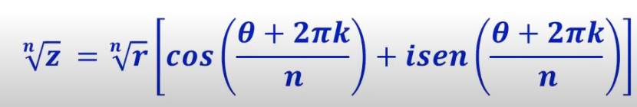

**r=(re^2+ima^2)^(1/2);**

phi=atan2(ima,re);

n=2

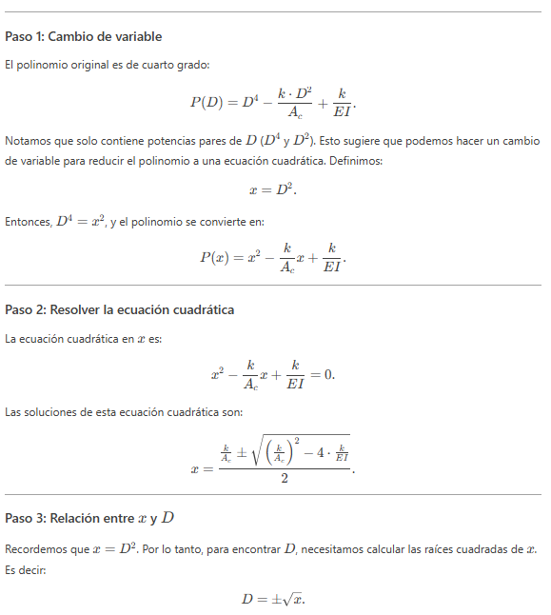

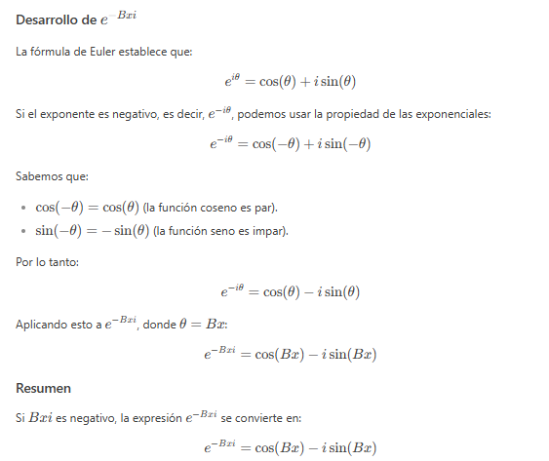

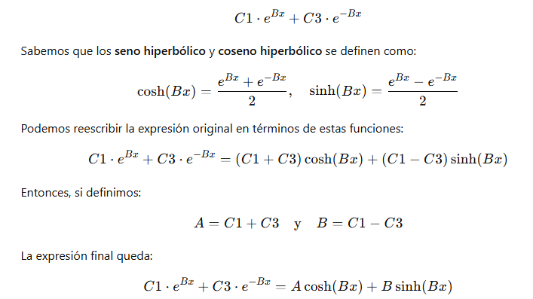

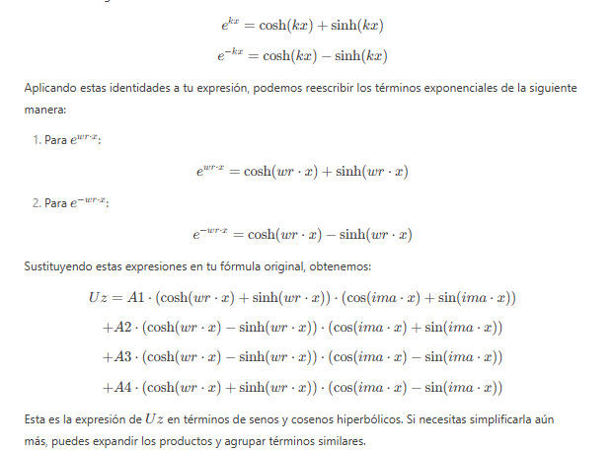

**wr=r^(1/n)*(cos((phi+2*pi*k1)/n)); parte real**

**wi=-r^(1/n)*(sin((phi+2*pi*k1)/n)); parte imaginaria**

**solución exponencial y trigonométrica senos y cosenos**

M=cos(wi*x)*(C1*exp(wr*x)+C2*exp(-wr*x))+sin(wi*x)*(C3*exp(wr*x)+C4*exp(-wr*x));

**solución exponencial y trigonométrica senos hiperbólicos y cosenos hiperbólicos**

M=cos(wi*x)*(C1*cosh(wr*x)+C2*sinh(wr*x))+sin(wi*x)*(C3*cosh(wr*x)+C4*sinh(wr*x));

Las ecuaciones de los demás términos se hallan como se indica

V=diff(M,x,1);

v=-diff(V,x,1)/k;

t=V/Ac+diff(v,x,1);

ya luego se plantean las condiciones para hallar las constantes de integración

**Ecuación diferencial para resolver la viga de wincler solucionado el sistema de ecuaciones**

**%V' == -k*v+q (1)**

**%M' == V (2)**

**%t' == M/EI (3)**

**%v' == t - V/Ac (4)**

**Obtengo los coeficientes de las ecuaciones y armo la matriz**

**V M t v**

val= [ 0,0 ,0 ,-k;

1,0 ,0 ,0;

0,1/EI,0 ,0;

-1/Ac, 0 ,1 ,0];

val2=[landa,0 ,0 ,0;

0 ,landa,0 ,0;

0 ,0 ,landa,0;

0 ,0 ,0 ,landa];

val3=det(val-val2);

sol= solve(val3==0)

(Ac*EI*landa^4 - EI*k*landa^2 + Ac*k)/(Ac*EI)==0

clc

clear

syms C1 C2 C3 C4 x A B C D k Ac EI L M k1 re ima xi

E = 24855578; % [kPa] modulo de elasticidad del concreto (NSR 10 - art C.8.5)

G = 0.4*E; % [kPa] modulo de cortante (NSR 10 - art CR8.8.2)

L = 4; % [m] longitud

Ae = 0.4^2; % [m^2] area

I = 0.4^4/12; % [m^4] inercia

Ac=Ae*G*5/6; % coeficiente de correccion del cortante para seccion rectangular

k=500;

EI=E*I;

re=k/(2*Ac);

ima=-(-k^2/(Ac^2*4)+(k)/(EI))^(1/2);

n=2;

r=(re^2+ima^2)^(1/2);

phi=atan2(ima,re);

k1=0;

wr=r^(1/n)*(cos((phi+2*pi*k1)/n));

wi=-r^(1/n)*(sin((phi+2*pi*k1)/n));

M=cos(wi*x)*(C1*cosh(wr*x)+C2*sinh(wr*x))+sin(wi*x)*(C3*cosh(wr*x)+C4*sinh(wr*x));

V=cos(x*sin(atan2(-2*(k/EI - k^2/(4*Ac^2))^(1/2), k/Ac)/2)*(k/EI)^(1/4))*(C2*cos(atan2(-2*(k/EI - k^2/(4*Ac^2))^(1/2), k/Ac)/2)*cosh(x*cos(atan2(-2*(k/EI - k^2/(4*Ac^2))^(1/2), k/Ac)/2)*(k/EI)^(1/4))*(k/EI)^(1/4) + C1*cos(atan2(-2*(k/EI - k^2/(4*Ac^2))^(1/2), k/Ac)/2)*sinh(x*cos(atan2(-2*(k/EI - k^2/(4*Ac^2))^(1/2), k/Ac)/2)*(k/EI)^(1/4))*(k/EI)^(1/4)) - sin(x*sin(atan2(-2*(k/EI - k^2/(4*Ac^2))^(1/2), k/Ac)/2)*(k/EI)^(1/4))*(C4*cos(atan2(-2*(k/EI - k^2/(4*Ac^2))^(1/2), k/Ac)/2)*cosh(x*cos(atan2(-2*(k/EI - k^2/(4*Ac^2))^(1/2), k/Ac)/2)*(k/EI)^(1/4))*(k/EI)^(1/4) + C3*cos(atan2(-2*(k/EI - k^2/(4*Ac^2))^(1/2), k/Ac)/2)*sinh(x*cos(atan2(-2*(k/EI - k^2/(4*Ac^2))^(1/2), k/Ac)/2)*(k/EI)^(1/4))*(k/EI)^(1/4)) - sin(atan2(-2*(k/EI - k^2/(4*Ac^2))^(1/2), k/Ac)/2)*cos(x*sin(atan2(-2*(k/EI - k^2/(4*Ac^2))^(1/2), k/Ac)/2)*(k/EI)^(1/4))*(C4*sinh(x*cos(atan2(-2*(k/EI - k^2/(4*Ac^2))^(1/2), k/Ac)/2)*(k/EI)^(1/4)) + C3*cosh(x*cos(atan2(-2*(k/EI - k^2/(4*Ac^2))^(1/2), k/Ac)/2)*(k/EI)^(1/4)))*(k/EI)^(1/4) - sin(atan2(-2*(k/EI - k^2/(4*Ac^2))^(1/2), k/Ac)/2)*sin(x*sin(atan2(-2*(k/EI - k^2/(4*Ac^2))^(1/2), k/Ac)/2)*(k/EI)^(1/4))*(C2*sinh(x*cos(atan2(-2*(k/EI - k^2/(4*Ac^2))^(1/2), k/Ac)/2)*(k/EI)^(1/4)) + C1*cosh(x*cos(atan2(-2*(k/EI - k^2/(4*Ac^2))^(1/2), k/Ac)/2)*(k/EI)^(1/4)))*(k/EI)^(1/4);

v=(C4*cosh(x*cos(angle((k - Ac*(-(k*(- 4*Ac^2 + EI*k))/(Ac^2*EI))^(1/2)*1i)/Ac)/2)*(k/EI)^(1/4))*cos(x*sin(angle((k - Ac*(-(k*(- 4*Ac^2 + EI*k))/(Ac^2*EI))^(1/2)*1i)/Ac)/2)*(k/EI)^(1/4))*imag((k - Ac*(-(k*(- 4*Ac^2 + EI*k))/(Ac^2*EI))^(1/2)*1i)/Ac)*abs(Ac)*(k/EI)^(1/2) - C1*cosh(x*cos(angle((k - Ac*(-(k*(- 4*Ac^2 + EI*k))/(Ac^2*EI))^(1/2)*1i)/Ac)/2)*(k/EI)^(1/4))*cos(x*sin(angle((k - Ac*(-(k*(- 4*Ac^2 + EI*k))/(Ac^2*EI))^(1/2)*1i)/Ac)/2)*(k/EI)^(1/4))*real((k - Ac*(-(k*(- 4*Ac^2 + EI*k))/(Ac^2*EI))^(1/2)*1i)/Ac)*abs(Ac)*(k/EI)^(1/2) + C2*cosh(x*cos(angle((k - Ac*(-(k*(- 4*Ac^2 + EI*k))/(Ac^2*EI))^(1/2)*1i)/Ac)/2)*(k/EI)^(1/4))*imag((k - Ac*(-(k*(- 4*Ac^2 + EI*k))/(Ac^2*EI))^(1/2)*1i)/Ac)*sin(x*sin(angle((k - Ac*(-(k*(- 4*Ac^2 + EI*k))/(Ac^2*EI))^(1/2)*1i)/Ac)/2)*(k/EI)^(1/4))*abs(Ac)*(k/EI)^(1/2) + C3*cos(x*sin(angle((k - Ac*(-(k*(- 4*Ac^2 + EI*k))/(Ac^2*EI))^(1/2)*1i)/Ac)/2)*(k/EI)^(1/4))*sinh(x*cos(angle((k - Ac*(-(k*(- 4*Ac^2 + EI*k))/(Ac^2*EI))^(1/2)*1i)/Ac)/2)*(k/EI)^(1/4))*imag((k - Ac*(-(k*(- 4*Ac^2 + EI*k))/(Ac^2*EI))^(1/2)*1i)/Ac)*abs(Ac)*(k/EI)^(1/2) - C2*cos(x*sin(angle((k - Ac*(-(k*(- 4*Ac^2 + EI*k))/(Ac^2*EI))^(1/2)*1i)/Ac)/2)*(k/EI)^(1/4))*sinh(x*cos(angle((k - Ac*(-(k*(- 4*Ac^2 + EI*k))/(Ac^2*EI))^(1/2)*1i)/Ac)/2)*(k/EI)^(1/4))*real((k - Ac*(-(k*(- 4*Ac^2 + EI*k))/(Ac^2*EI))^(1/2)*1i)/Ac)*abs(Ac)*(k/EI)^(1/2) + C3*cosh(x*cos(angle((k - Ac*(-(k*(- 4*Ac^2 + EI*k))/(Ac^2*EI))^(1/2)*1i)/Ac)/2)*(k/EI)^(1/4))*sin(x*sin(angle((k - Ac*(-(k*(- 4*Ac^2 + EI*k))/(Ac^2*EI))^(1/2)*1i)/Ac)/2)*(k/EI)^(1/4))*real((k - Ac*(-(k*(- 4*Ac^2 + EI*k))/(Ac^2*EI))^(1/2)*1i)/Ac)*abs(Ac)*(k/EI)^(1/2) + C1*sinh(x*cos(angle((k - Ac*(-(k*(- 4*Ac^2 + EI*k))/(Ac^2*EI))^(1/2)*1i)/Ac)/2)*(k/EI)^(1/4))*imag((k - Ac*(-(k*(- 4*Ac^2 + EI*k))/(Ac^2*EI))^(1/2)*1i)/Ac)*sin(x*sin(angle((k - Ac*(-(k*(- 4*Ac^2 + EI*k))/(Ac^2*EI))^(1/2)*1i)/Ac)/2)*(k/EI)^(1/4))*abs(Ac)*(k/EI)^(1/2) + C4*sinh(x*cos(angle((k - Ac*(-(k*(- 4*Ac^2 + EI*k))/(Ac^2*EI))^(1/2)*1i)/Ac)/2)*(k/EI)^(1/4))*sin(x*sin(angle((k - Ac*(-(k*(- 4*Ac^2 + EI*k))/(Ac^2*EI))^(1/2)*1i)/Ac)/2)*(k/EI)^(1/4))*real((k - Ac*(-(k*(- 4*Ac^2 + EI*k))/(Ac^2*EI))^(1/2)*1i)/Ac)*abs(Ac)*(k/EI)^(1/2))/(k*abs(k - Ac*(-(k*(- 4*Ac^2 + EI*k))/(Ac^2*EI))^(1/2)*1i));

t=- (- cos(x*sin(atan2(-2*(k/EI - k^2/(4*Ac^2))^(1/2), k/Ac)/2)*(k/EI)^(1/4))*(C2*cos(atan2(-2*(k/EI - k^2/(4*Ac^2))^(1/2), k/Ac)/2)*cosh(x*cos(atan2(-2*(k/EI - k^2/(4*Ac^2))^(1/2), k/Ac)/2)*(k/EI)^(1/4))*(k/EI)^(1/4) + C1*cos(atan2(-2*(k/EI - k^2/(4*Ac^2))^(1/2), k/Ac)/2)*sinh(x*cos(atan2(-2*(k/EI - k^2/(4*Ac^2))^(1/2), k/Ac)/2)*(k/EI)^(1/4))*(k/EI)^(1/4)) + sin(x*sin(atan2(-2*(k/EI - k^2/(4*Ac^2))^(1/2), k/Ac)/2)*(k/EI)^(1/4))*(C4*cos(atan2(-2*(k/EI - k^2/(4*Ac^2))^(1/2), k/Ac)/2)*cosh(x*cos(atan2(-2*(k/EI - k^2/(4*Ac^2))^(1/2), k/Ac)/2)*(k/EI)^(1/4))*(k/EI)^(1/4) + C3*cos(atan2(-2*(k/EI - k^2/(4*Ac^2))^(1/2), k/Ac)/2)*sinh(x*cos(atan2(-2*(k/EI - k^2/(4*Ac^2))^(1/2), k/Ac)/2)*(k/EI)^(1/4))*(k/EI)^(1/4)) + sin(atan2(-2*(k/EI - k^2/(4*Ac^2))^(1/2), k/Ac)/2)*cos(x*sin(atan2(-2*(k/EI - k^2/(4*Ac^2))^(1/2), k/Ac)/2)*(k/EI)^(1/4))*(C4*sinh(x*cos(atan2(-2*(k/EI - k^2/(4*Ac^2))^(1/2), k/Ac)/2)*(k/EI)^(1/4)) + C3*cosh(x*cos(atan2(-2*(k/EI - k^2/(4*Ac^2))^(1/2), k/Ac)/2)*(k/EI)^(1/4)))*(k/EI)^(1/4) + sin(atan2(-2*(k/EI - k^2/(4*Ac^2))^(1/2), k/Ac)/2)*sin(x*sin(atan2(-2*(k/EI - k^2/(4*Ac^2))^(1/2), k/Ac)/2)*(k/EI)^(1/4))*(C2*sinh(x*cos(atan2(-2*(k/EI - k^2/(4*Ac^2))^(1/2), k/Ac)/2)*(k/EI)^(1/4)) + C1*cosh(x*cos(atan2(-2*(k/EI - k^2/(4*Ac^2))^(1/2), k/Ac)/2)*(k/EI)^(1/4)))*(k/EI)^(1/4))/Ac + (sin(x*sin(atan2(-2*(k/EI - k^2/(4*Ac^2))^(1/2), k/Ac)/2)*(k/EI)^(1/4))*(C4*cos(atan2(-2*(k/EI - k^2/(4*Ac^2))^(1/2), k/Ac)/2)^3*cosh(x*cos(atan2(-2*(k/EI - k^2/(4*Ac^2))^(1/2), k/Ac)/2)*(k/EI)^(1/4))*(k/EI)^(3/4) + C3*cos(atan2(-2*(k/EI - k^2/(4*Ac^2))^(1/2), k/Ac)/2)^3*sinh(x*cos(atan2(-2*(k/EI - k^2/(4*Ac^2))^(1/2), k/Ac)/2)*(k/EI)^(1/4))*(k/EI)^(3/4)) - cos(x*sin(atan2(-2*(k/EI - k^2/(4*Ac^2))^(1/2), k/Ac)/2)*(k/EI)^(1/4))*(C2*cos(atan2(-2*(k/EI - k^2/(4*Ac^2))^(1/2), k/Ac)/2)^3*cosh(x*cos(atan2(-2*(k/EI - k^2/(4*Ac^2))^(1/2), k/Ac)/2)*(k/EI)^(1/4))*(k/EI)^(3/4) + C1*cos(atan2(-2*(k/EI - k^2/(4*Ac^2))^(1/2), k/Ac)/2)^3*sinh(x*cos(atan2(-2*(k/EI - k^2/(4*Ac^2))^(1/2), k/Ac)/2)*(k/EI)^(1/4))*(k/EI)^(3/4)) + 3*sin(atan2(-2*(k/EI - k^2/(4*Ac^2))^(1/2), k/Ac)/2)*cos(x*sin(atan2(-2*(k/EI - k^2/(4*Ac^2))^(1/2), k/Ac)/2)*(k/EI)^(1/4))*(C3*cos(atan2(-2*(k/EI - k^2/(4*Ac^2))^(1/2), k/Ac)/2)^2*cosh(x*cos(atan2(-2*(k/EI - k^2/(4*Ac^2))^(1/2), k/Ac)/2)*(k/EI)^(1/4))*(k/EI)^(1/2) + C4*cos(atan2(-2*(k/EI - k^2/(4*Ac^2))^(1/2), k/Ac)/2)^2*sinh(x*cos(atan2(-2*(k/EI - k^2/(4*Ac^2))^(1/2), k/Ac)/2)*(k/EI)^(1/4))*(k/EI)^(1/2))*(k/EI)^(1/4) + 3*sin(atan2(-2*(k/EI - k^2/(4*Ac^2))^(1/2), k/Ac)/2)*sin(x*sin(atan2(-2*(k/EI - k^2/(4*Ac^2))^(1/2), k/Ac)/2)*(k/EI)^(1/4))*(C1*cos(atan2(-2*(k/EI - k^2/(4*Ac^2))^(1/2), k/Ac)/2)^2*cosh(x*cos(atan2(-2*(k/EI - k^2/(4*Ac^2))^(1/2), k/Ac)/2)*(k/EI)^(1/4))*(k/EI)^(1/2) + C2*cos(atan2(-2*(k/EI - k^2/(4*Ac^2))^(1/2), k/Ac)/2)^2*sinh(x*cos(atan2(-2*(k/EI - k^2/(4*Ac^2))^(1/2), k/Ac)/2)*(k/EI)^(1/4))*(k/EI)^(1/2))*(k/EI)^(1/4) - sin(atan2(-2*(k/EI - k^2/(4*Ac^2))^(1/2), k/Ac)/2)^3*cos(x*sin(atan2(-2*(k/EI - k^2/(4*Ac^2))^(1/2), k/Ac)/2)*(k/EI)^(1/4))*(C4*sinh(x*cos(atan2(-2*(k/EI - k^2/(4*Ac^2))^(1/2), k/Ac)/2)*(k/EI)^(1/4)) + C3*cosh(x*cos(atan2(-2*(k/EI - k^2/(4*Ac^2))^(1/2), k/Ac)/2)*(k/EI)^(1/4)))*(k/EI)^(3/4) - sin(atan2(-2*(k/EI - k^2/(4*Ac^2))^(1/2), k/Ac)/2)^3*sin(x*sin(atan2(-2*(k/EI - k^2/(4*Ac^2))^(1/2), k/Ac)/2)*(k/EI)^(1/4))*(C2*sinh(x*cos(atan2(-2*(k/EI - k^2/(4*Ac^2))^(1/2), k/Ac)/2)*(k/EI)^(1/4)) + C1*cosh(x*cos(atan2(-2*(k/EI - k^2/(4*Ac^2))^(1/2), k/Ac)/2)*(k/EI)^(1/4)))*(k/EI)^(3/4) + 3*sin(atan2(-2*(k/EI - k^2/(4*Ac^2))^(1/2), k/Ac)/2)^2*cos(x*sin(atan2(-2*(k/EI - k^2/(4*Ac^2))^(1/2), k/Ac)/2)*(k/EI)^(1/4))*(k/EI)^(1/2)*(C2*cos(atan2(-2*(k/EI - k^2/(4*Ac^2))^(1/2), k/Ac)/2)*cosh(x*cos(atan2(-2*(k/EI - k^2/(4*Ac^2))^(1/2), k/Ac)/2)*(k/EI)^(1/4))*(k/EI)^(1/4) + C1*cos(atan2(-2*(k/EI - k^2/(4*Ac^2))^(1/2), k/Ac)/2)*sinh(x*cos(atan2(-2*(k/EI - k^2/(4*Ac^2))^(1/2), k/Ac)/2)*(k/EI)^(1/4))*(k/EI)^(1/4)) - 3*sin(atan2(-2*(k/EI - k^2/(4*Ac^2))^(1/2), k/Ac)/2)^2*sin(x*sin(atan2(-2*(k/EI - k^2/(4*Ac^2))^(1/2), k/Ac)/2)*(k/EI)^(1/4))*(k/EI)^(1/2)*(C4*cos(atan2(-2*(k/EI - k^2/(4*Ac^2))^(1/2), k/Ac)/2)*cosh(x*cos(atan2(-2*(k/EI - k^2/(4*Ac^2))^(1/2), k/Ac)/2)*(k/EI)^(1/4))*(k/EI)^(1/4) + C3*cos(atan2(-2*(k/EI - k^2/(4*Ac^2))^(1/2), k/Ac)/2)*sinh(x*cos(atan2(-2*(k/EI - k^2/(4*Ac^2))^(1/2), k/Ac)/2)*(k/EI)^(1/4))*(k/EI)^(1/4)))/k;

K_TE2 = (zeros(6));

N_w2 = sym(zeros(1,6));

N_t2 = sym(zeros(1,6));

for i = 1:6

[c1,c2,c3,c4]=solve(subs(v,x,0)==(i==2),...

subs(t,x,0)==(i==3),...

subs(v,x,L)==(i==5),...

subs(t,x,L)==(i==6),...

[C1,C2,C3,C4]);

N_t2(i) = subs(t,{C1,C2,C3,C4,x},{c1,c2,c3,c4,L*(1+xi)/2});

N_w2(i) = subs(v,{C1,C2,C3,C4,x},{c1,c2,c3,c4,L*(1+xi)/2});

% # se evaluan las reacciones horizontales y verticales y los momentos en los apoyos

K_TE2(:,i)=double(([ 0;

subs(V,{C1,C2,C3,C4,x},{c1,c2,c3,c4,0}); % Y2

-subs(M,{C1,C2,C3,C4,x},{c1,c2,c3,c4,0}); % M2

0;

-subs(V,{C1,C2,C3,C4,x},{c1,c2,c3,c4,L}); % Y2

subs(M,{C1,C2,C3,C4,x},{c1,c2,c3,c4,L})]));% M2

end

syms xi

%# Se convierten las funciones de forma a coordenadas naturales,

%% Funciones de forma

N_u2 =[ 1/2 - xi/2, 0, 0, xi/2 + 1/2, 0, 0];

%N_u2 = simplify(subs(N_u2,x, L*(1+xi)/2));

%N_w2 = simplify(subs(N_w2,x, L*(1+xi)/2)); %# x = L*xi/2 + L/2

%N_t2 = simplify(subs(N_t2,x, L*(1+xi)/2));

N1 = vertcat(N_u2,N_w2);

N2= vertcat(N_t2);

%% Derivadas funciones de forma

dx_dxi = L/2; % jacobiano de la transformacion isoparametrico

dN_u2 = diff(N_u2,1,xi)/dx_dxi;

dN_w2 = diff(N_w2,1,xi)/dx_dxi;

dN_t2 = diff(N_t2,1,xi)/dx_dxi;

%% MOMENTOS DE EMPOTRAMIENTO

ba = 25; % [kN/m] carga uniforme distribuida vertical inicial

bb = 40;

b = (bb-ba)*x/L +ba; % [kN/m] carga uniforme distribuida axial

wa = 25; % [kN/m] carga uniforme distribuida vertical inicial

wb = 40; % [kN/m] carga uniforme distribuida vertical final

w =(wb-wa)*x/L + wa; % carga trapezoidal

wf = simplify(subs(w,x, L*(1+xi)/2));

bf = simplify(subs(b,x, L*(1+xi)/2));

MV = double(int(N_u2'*bf*dx_dxi + N_w2'*wf*dx_dxi,xi,-1,1));